**Power and GPIO Circuits**

*Alex Sternberg*

005412076

**Abstract**

*This implementation of filtered power regulation and testing GPIO devices. A 7805 provides a 5 V source with less than 50 mV of drift. An input is provided by a SPDT switch tied to Vcc and GND. The output is a sunk LED.*

**Introduction**

The first step in a towards having a usable microcontroller platform is having dependable power. Leveraging the well-known nature of the LM7805 to providing a very stable 5 V output. In this case, we used a STMicroelectronics L7805CV to regulate voltage. This TO-220 package can dissipate 0.5W without a heatsink delivering up to 100 mA to the circuit. Accessory devices have been added to indicate the status of applied power and provide the MCU with inputs and outputs for testing basic software applications.

**Circuit Diagrams**

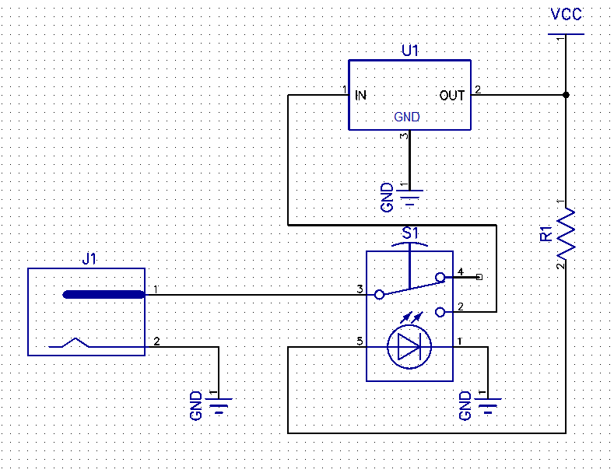

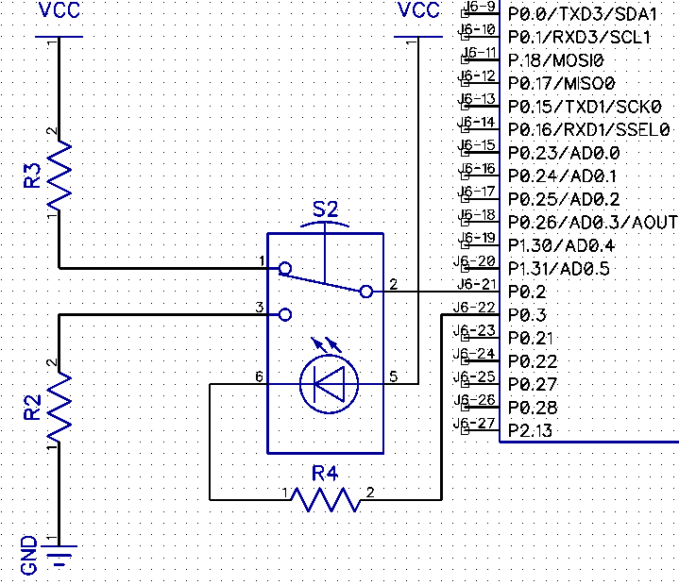

**Board Layout**

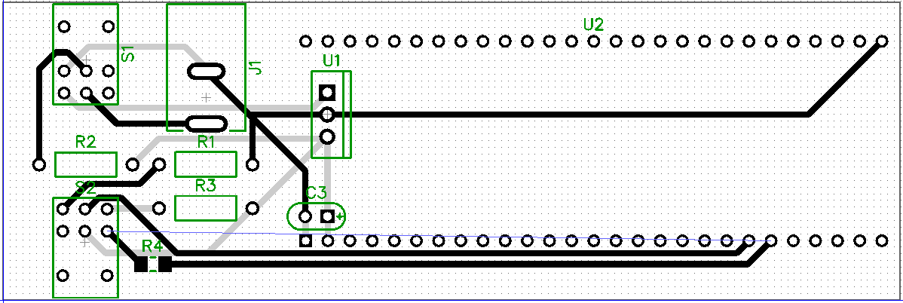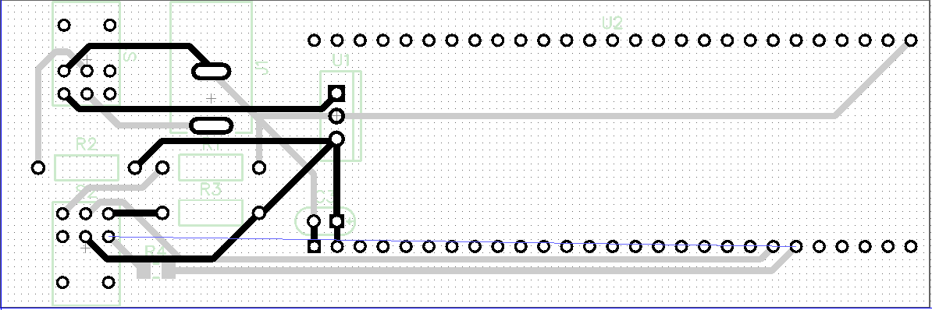

**Pin Connection Table**

|  |  |  |  |
| --- | --- | --- | --- |
| Pin | Purpose | Pin | Purpose |
| J6-21 | GPIO-Input | S2-2 | Switch Common Pole |
| J6-22 | GPIO-Output | R4 | Current Limiting Resistor |
| J6-1 | GND | U1-2 | GND |
| J6-2 | Vcc | U1-3 | 5V Output |
| J6-54 | GND | U1-2 | GND |

**Bill of Materials**

|  |  |  |  |  |
| --- | --- | --- | --- | --- |
| Manufacturer | Part Number | Quantity | Identifier | Description |
| CUI | CP-037A | 1 | J1 | 5.5 mm O.D. Power Connector | |
| STMicro | L7805CV | 1 | U1 | 5 V LDO Regulator | |
| TDK | FG14X7R1E475KRT06 | 1 | C1 | 4.7 uF Ceramic Capacitor | |
| TE | YR1B1K0CC | 2 | R1, R3 | 1 kOhm 1/4 W Resistor | |
| TE | YR1B150RCC | 1 | R2 | 150 Ohm 1/4 W Resistor | |
| TE | CRG1206F150R | 1 | R4 | 150 Ohm 1206 Resistor | |
| NKK | GW12LJHC | 1 | S1 | Rocker Switch, Red LED | |
| NKK | GW12LJHF | 1 | S2 | Rocker Switch, Green LED | |
| Samtek | TS-127-T-A | 2 |  | 0.100" 1x27 Headers | |
| Samtek | SSQ-127-03-G-S | 2 |  | 0.100" 1x27 Stackable Header | |

**Flowchart**

**C:\Users\nykos\Downloads\Untitled Diagram.png**

**Program**

#ifdef __USE_CMSIS

#include "LPC17xx.h"

#endif

#include <cr_section_macros.h>

#include <stdio.h>

void GPIOinitOut(uint8_t portNum, uint32_t pinNum){

if (portNum == 0){

LPC_GPIO0->FIODIR |= (1 << pinNum);

}

else if (portNum == 1){

LPC_GPIO1->FIODIR |= (1 << pinNum);

}

else if (portNum == 2){

LPC_GPIO2->FIODIR |= (1 << pinNum);

}

else{

puts("Not a valid port!\n");

}

}

void GPIOinitIn(uint8_t portNum, uint32_t pinNum){

if (portNum == 0){

LPC_GPIO0->FIODIR &= ~(1 << pinNum);

}

else if (portNum == 1){

LPC_GPIO1->FIODIR &= ~(1 << pinNum);

}

else if (portNum == 2){

LPC_GPIO2->FIODIR &= ~(1 << pinNum);

}

else{

puts("Not a valid port!\n");

}

}

void setGPIO(uint8_t portNum, uint32_t pinNum){

if (portNum == 0){

LPC_GPIO0->FIOSET = (1 << pinNum);

printf("Pin 0.%d has been set.\n",pinNum);

}

else{

puts("Only port 0 is used, try again!\n");

}

}

void clearGPIO(uint8_t portNum, uint32_t pinNum){

if (portNum == 0){

LPC_GPIO0->FIOCLR = (1 << pinNum);

printf("Pin 0.%d has been cleared.\n", pinNum);

}

else{

puts("Only port 0 is used, try again!\n");

}

}

int readGPIO(uint8_t portNum, uint32_t pinNum){

if (portNum == 0){

return ( LPC_GPIO0->FIOPIN & (1 << pinNum) ) >> pinNum;

}

else{

puts("Only port 0 is used, try again!\n");

return 0;

}

}

int main(void){

GPIOinitIn(0,2);

GPIOinitOut(0,3);

while(1){

if(readGPIO(0,2)) setGPIO(0,3);

else clearGPIO(0,3);

}

return 0;

}

**Testing and verification**

After analysis of the circuit, it was determined that there was an error in the fabricated circuit board. While subtle, it was determined that tying the GPIO input and output high lines through the same 150 Ω resistor created a situation in which sufficient voltage may not be available when both the LED indicator is on and the switch is high. Since the input and the LED are wired in parallel after the resistor, the voltage experienced by the input is only 2.1 V, equivalent to the drop across the LED. The datasheet for the LPC1769 dictates that VIL is 0.7 Vcc(3.3), corresponding to 2.3 V. Obviously, we cannot guarantee that in this edge case the LPC1769 will return the correct value. To remedy this, the trace between pins 3 and 5 of S2 has been removed. A wire has been added to bridge from the Vcc side of R3 to pin 5 of S2. Further the trace connecting pin 6 of S2 to J6-22 has been cut and the solder mask removed. A 1206 size 150 Ω resistor has been added to limit current through the LED.

Once the circuit was changed, basic functionality was tested by connecting pin 21 and 22 of U2 together with an ammeter. By switching S2 to ground, we can turn the LED on and see 20 mA flowing through it. By switching it to Vcc(5) we can turn it off.

**Conclusion**

Having stable power eliminates a source of issues that could plague a microcontroller. We built a circuit on the dependable LM7805 Linear Drop-Out Regulator, and added a 4.7 uF capacitor as a low-pass filter. We also added a switch and LED for I/O testing. This board provides the basic resources needed for running and testing the MCU. It able forms the basis of our future projects.